I chose Project 11 this week, the ‘pizza’ project. To be honest, I only had a vague idea about how I would implement the different requirements, so I began by creating the class and declaring the variables that I knew of. I started my work with a method to set the order based on input, then created another constructor for just passing in the pizza variables as arguments. Some of my methods for setting the size and calculating the cost were grouped into one method, and I separated them after remembering some advice about having methods just perform their simple functions and calling for them as needed. On that note, I’m not sure that my set and get methods are right. They do work, but I’m not sure if they should be stripped down and then called in other methods? I sent you an email to possibly review this before turning it in, but it was just Thursday night, and we weren’t able to get together on it in time. Looking forward to your feedback this week, and I’m doing the continuation of this problem for next week.

I’ve scheduled an appointment with the tutor listed for this class, Tom Lipovits. I am understanding some of the basic concepts, and I want to know more about best-practices and must-haves when I’m making classes.

**Screenshot of pizza class (1/2)**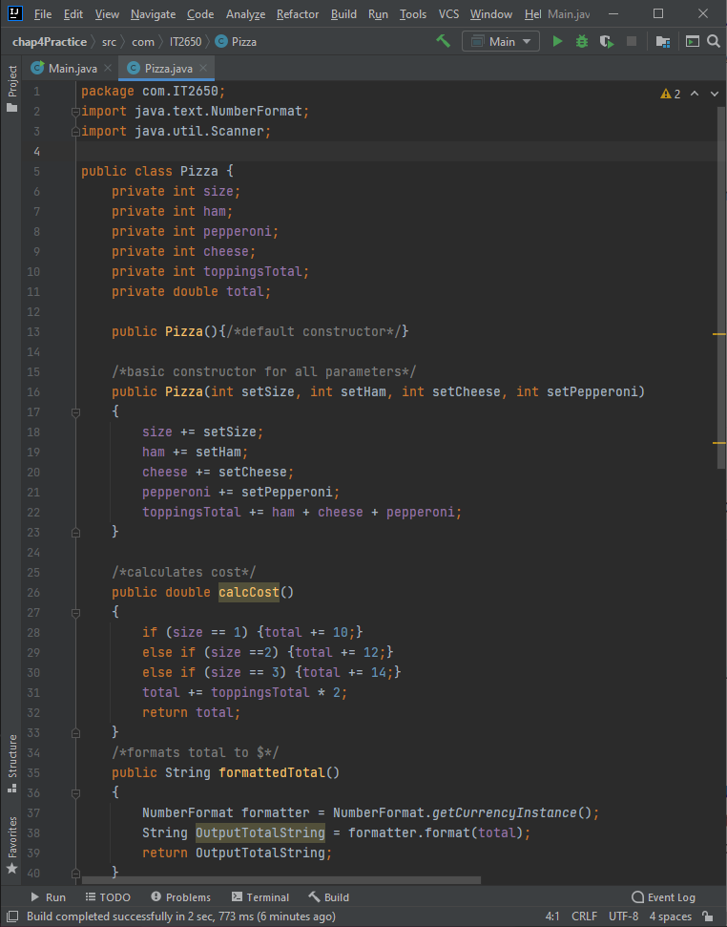

**Screenshot of pizza class (2/2)**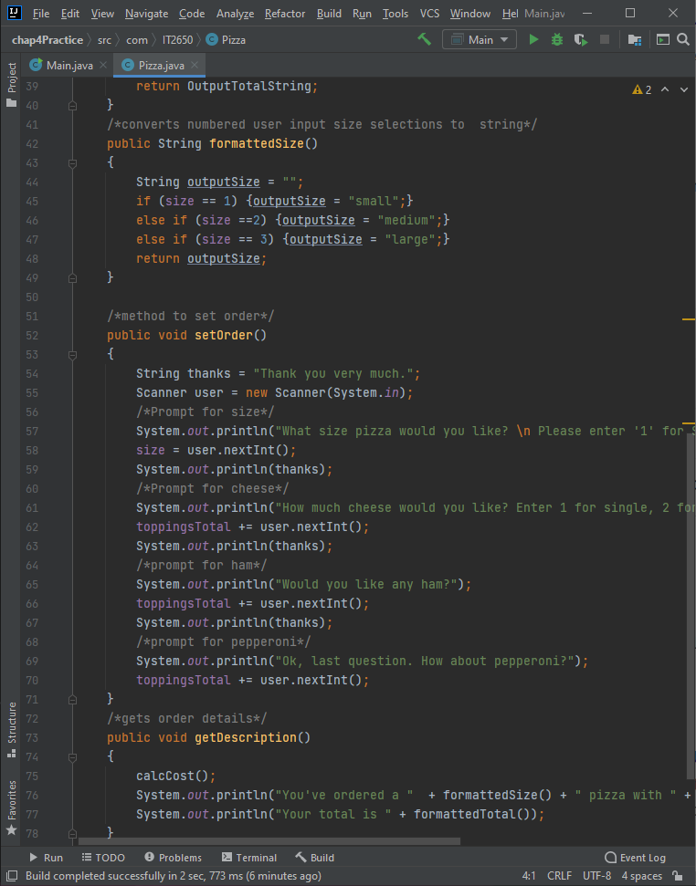

**Screenshot of main/test method**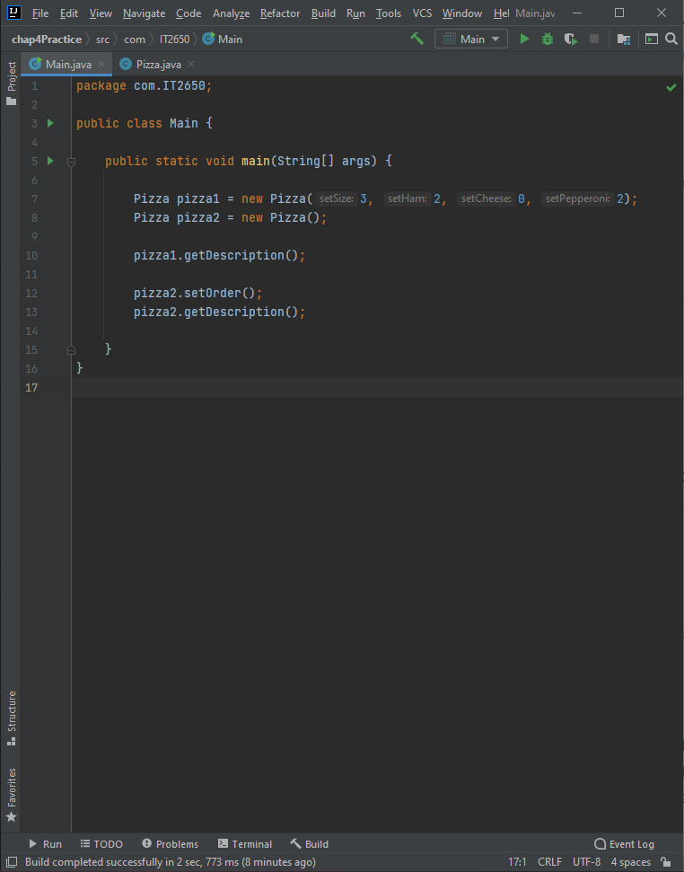

Thod

**Screenshot of program output**

